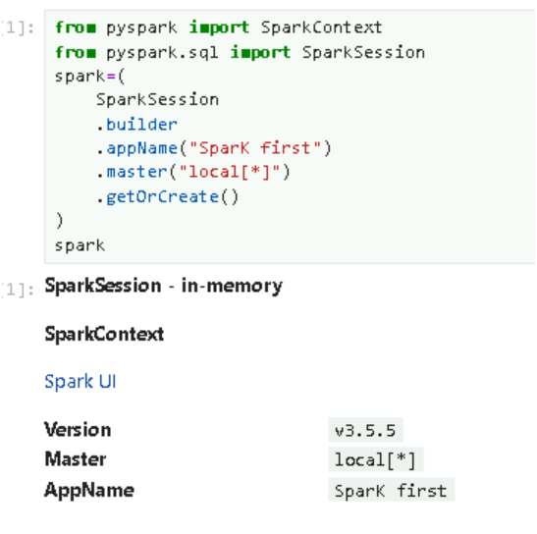**TRANSACTION DATASET-SPARK**

**READING DATASET**



**SCHEMA OF THE DATAFRAME**



